Link github: https://github.com/letterforyou26/AIMS_Project­

**I. Tạo các Template fxml**

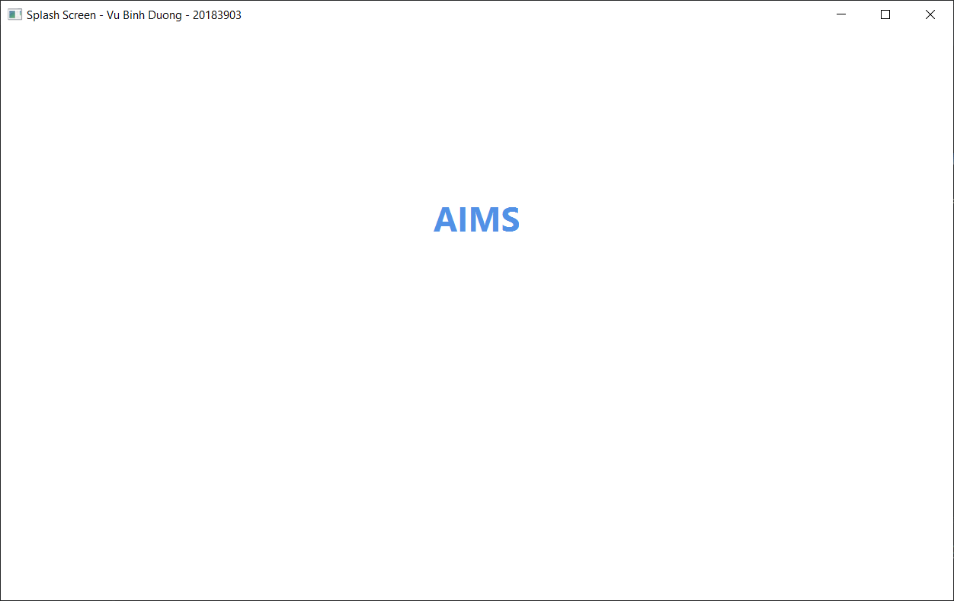

Hình 1.1. Splash screen

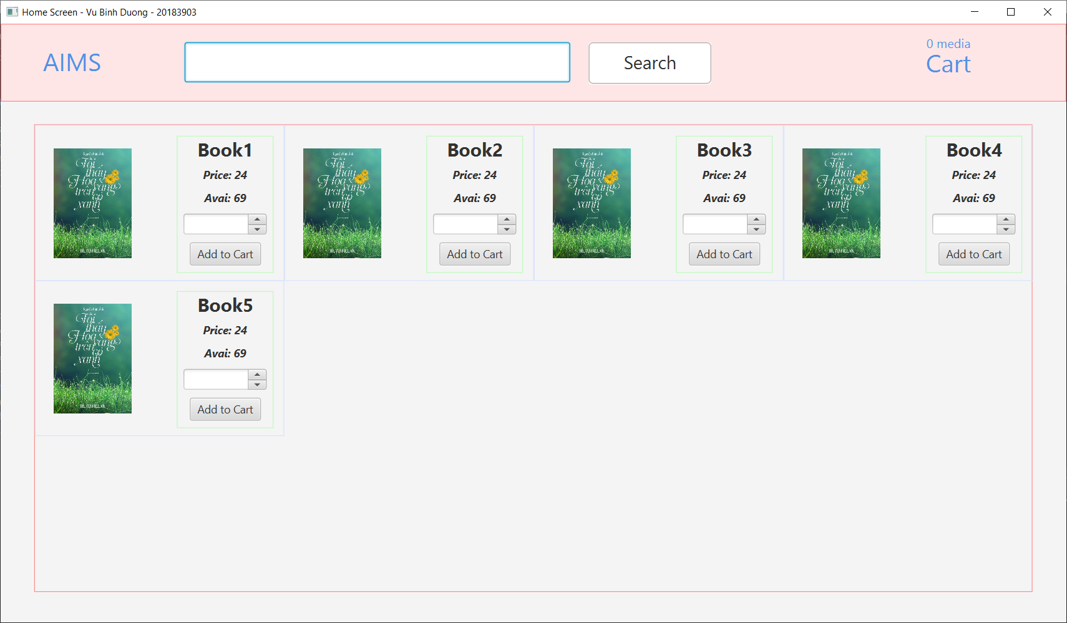

Hình 1.2. Home screen

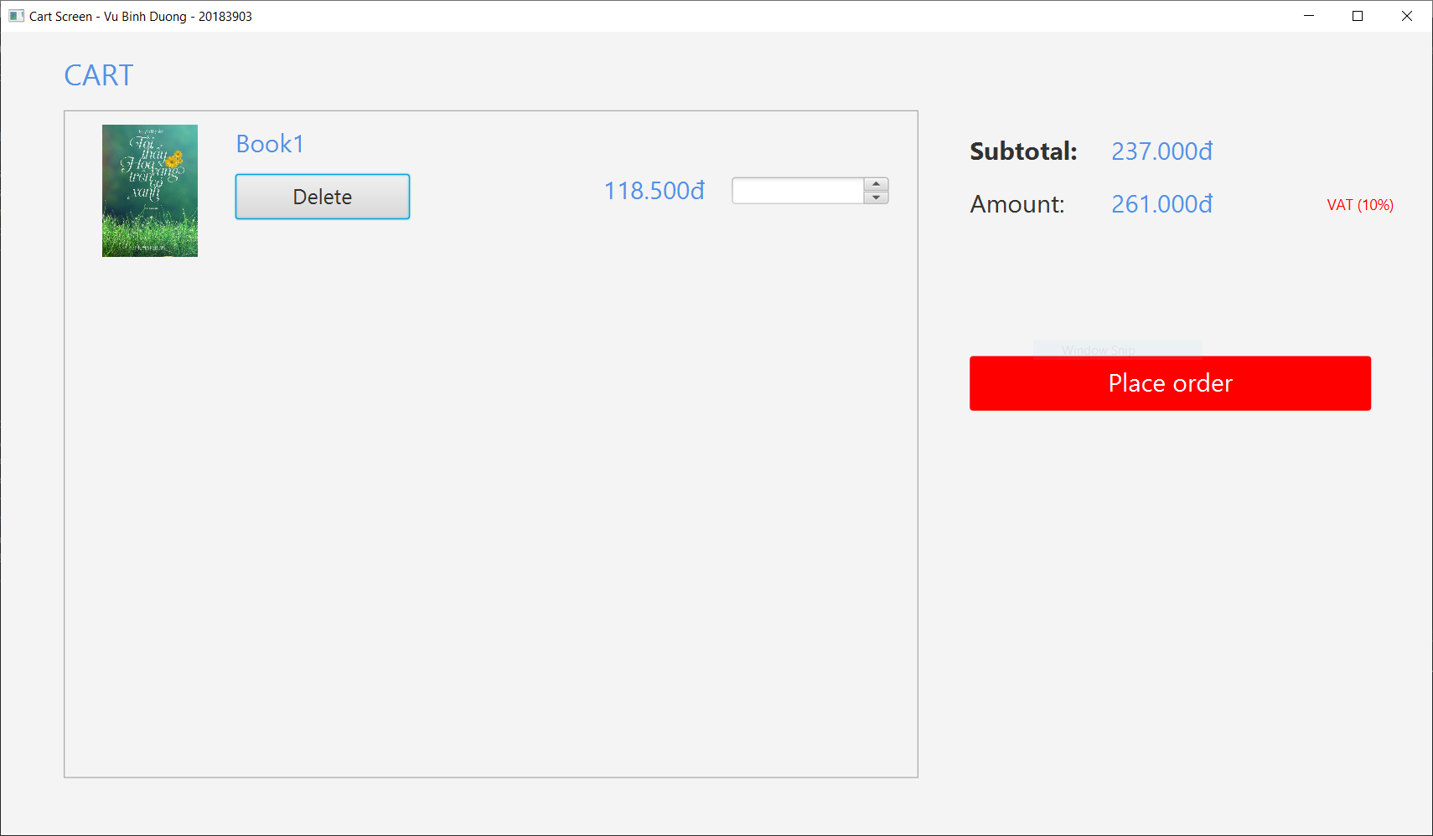

Hình 1.3. View cart screen

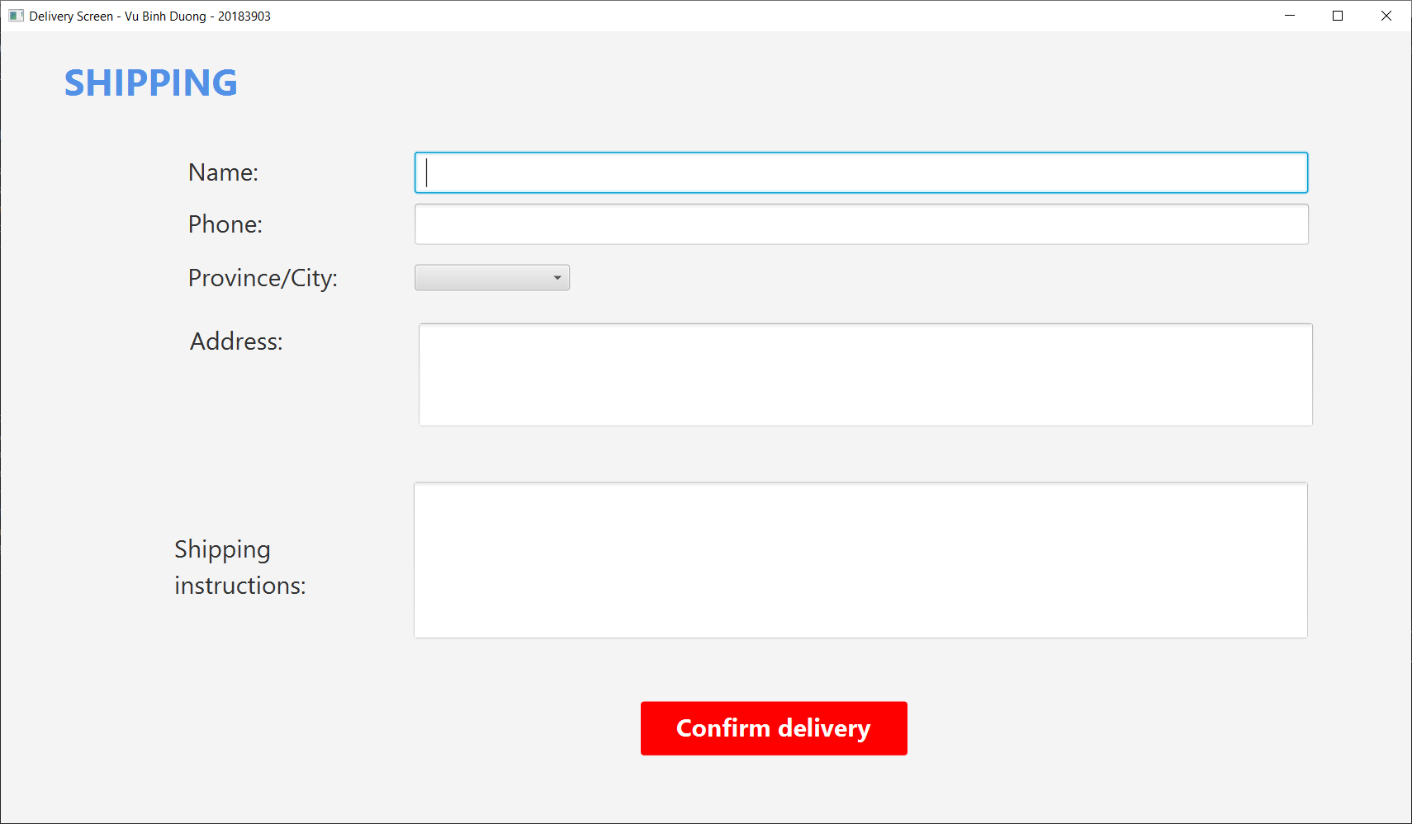

Hình 1.4. Delivery form

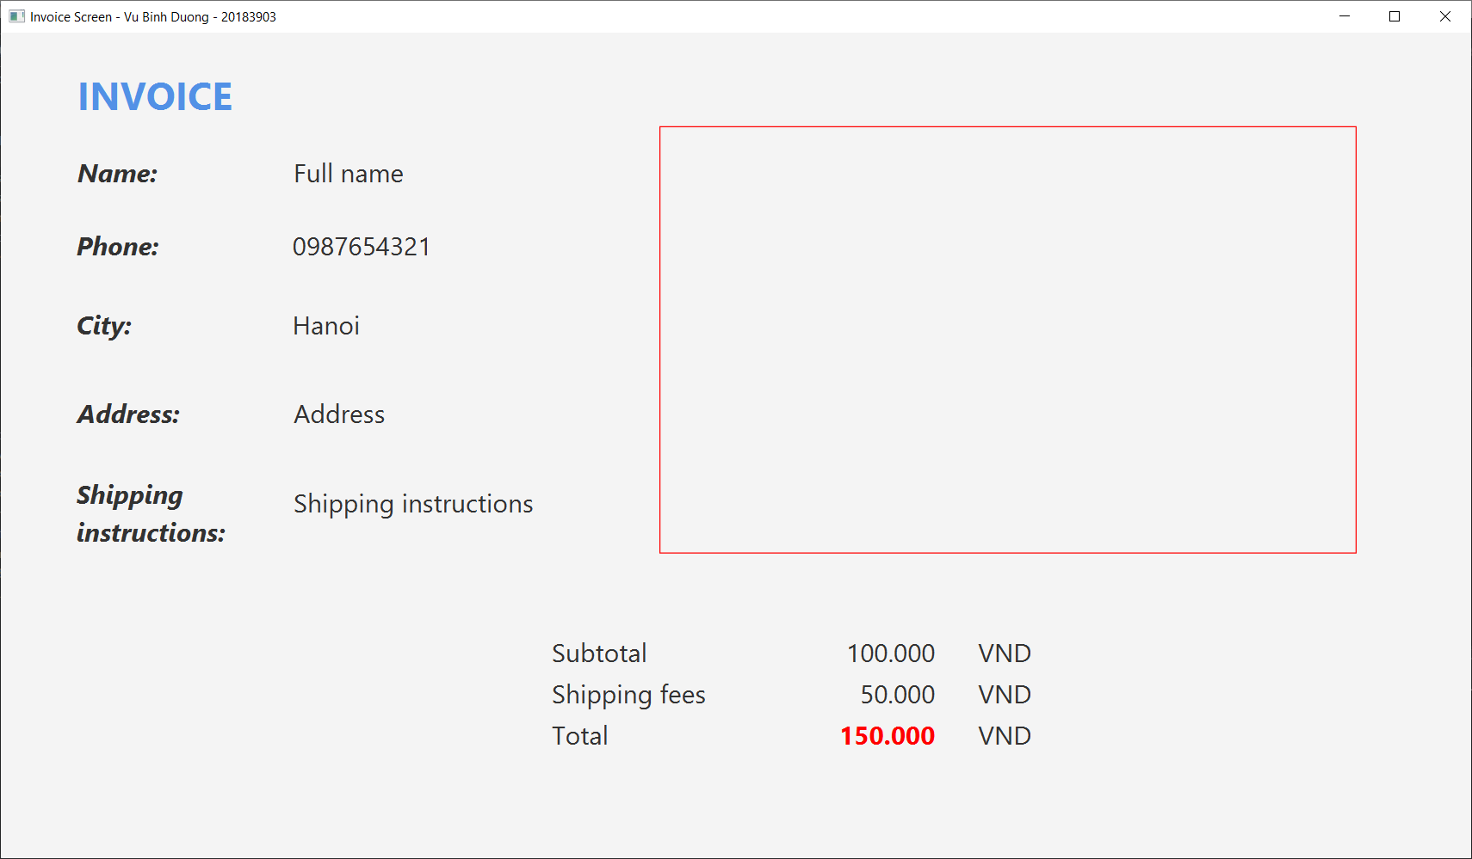

Hình 1.5. Invoice screen

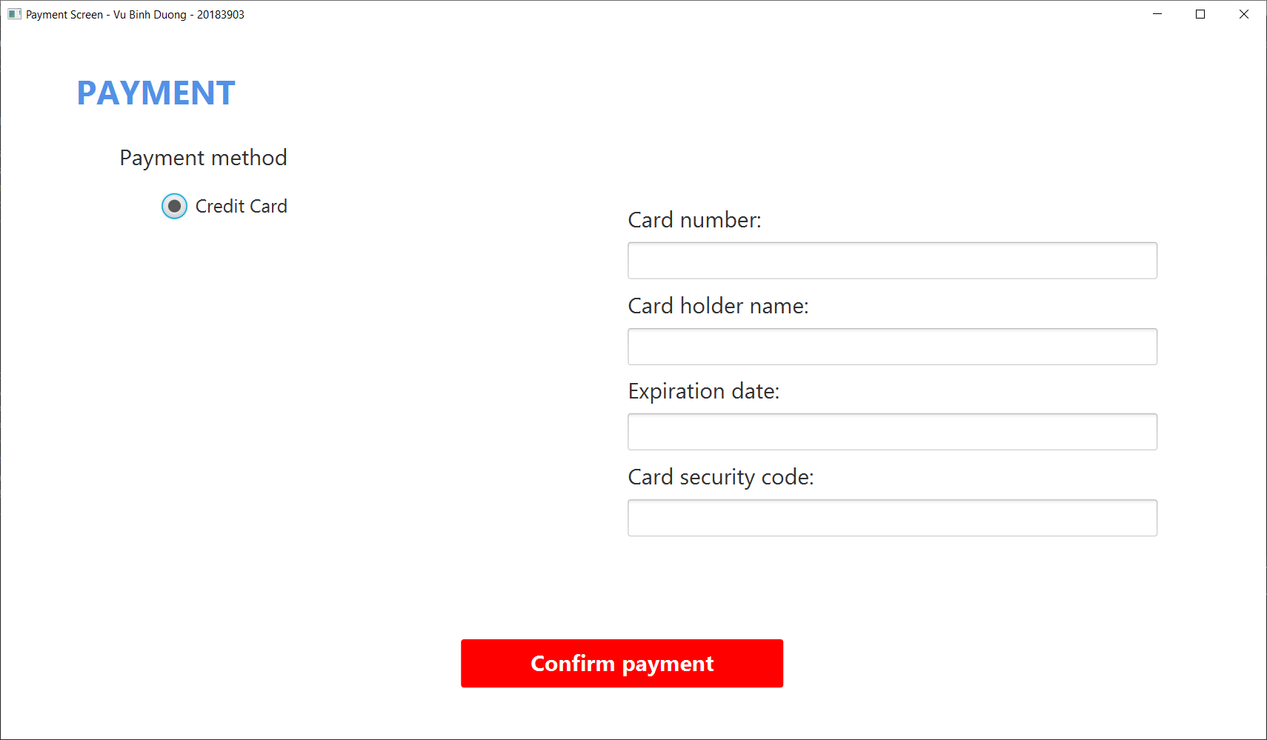

Hình 1.6. Payment form

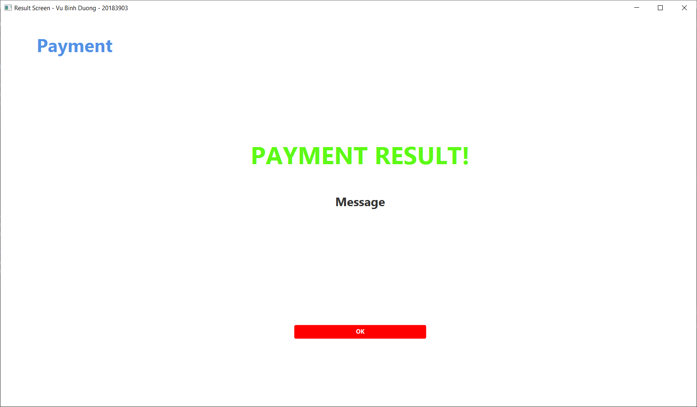

Hình 1.7. Result screen

**II. Thiết kế các dịch chuyển màn hình**

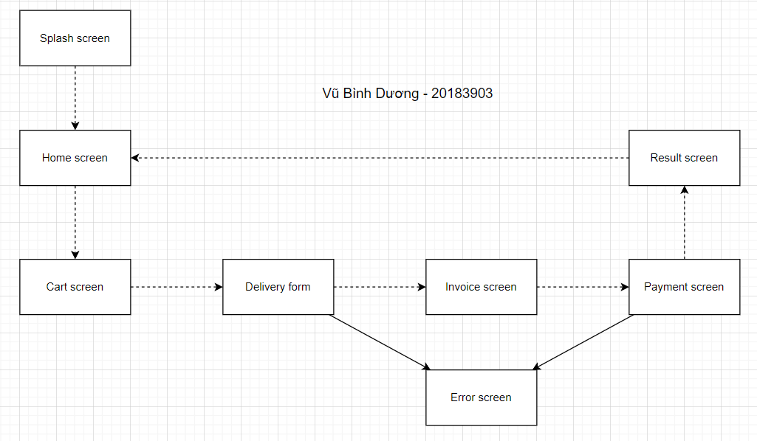

Hình 2. Sơ đồ chuyển màn hình

**III. Mô tả các màn hình**

1. *View cart screen*

|  |  |  |  |  |  |
| --- | --- | --- | --- | --- | --- |
| AIMS Software | | Date of creation | Approved by | Reviewed by | Person in charge |
| Screen specification | View Cart Screen | 2/11/2021 |  |  | Vũ Bình Dương |
|  | | Control | Operation | Function | |
| Area for displaying the subtotal | Initial | Display the subtotal | |
| Area for display items in the cart | Initial | Display the media with the corresponding information | |
| Place order button | Click | Display the Delivery form | |
| Delete button | Click | Remove the item from the cart | |

#### Định nghĩa các trường thuộc tính

|  |  |  |  |  |
| --- | --- | --- | --- | --- |
| Screen name | View cart |  |  |  |
| Item name | Number of digits (bytes) | Type | Field attribute | Remarks |
| Media title | 50 | Numeral | Blue | Left-justified |
| Price | 20 | Numeral | Blue | Right justified |
| Subtotal | 20 | Numeral | Blue | Left-justified |

1. *Home screen*

|  |  |  |  |  |  |
| --- | --- | --- | --- | --- | --- |
| AIMS Software | | Date of creation | Approved by | Reviewed by | Person in charge |
| Screen specification | Home Screen | 2/11/2021 |  |  | Vũ Bình Dương |
|  | | Cart icon button | Click | Redirect to View cart screen | |
| Input field for searching | None | Place to fill params to search | |
| Button search | Click | Search for media which name contains params | |
| Area for displaying list of book | Initial | Display details of list media | |
| Spinner | Click | Adjust the number of selected media | |
|  | | Add to cart button | Click | Add selected book to Cart | |

#### Định nghĩa các trường thuộc tính

|  |  |  |  |  |
| --- | --- | --- | --- | --- |
| Screen name | View cart |  |  |  |
| Item name | Number of digits (bytes) | Type | Field attribute | Remarks |
| Media title | 50 | Numeral | Bold, black | Center-justified |
| Price | 20 | Numeral | Inherit, black | Center-justified |
| Avail | 20 | Numeral | Inherit, black | Center-justified |
| Search params | 50 | String | Black | Left-justified |

1. *Shipping screen*

|  |  |  |  |  |  |
| --- | --- | --- | --- | --- | --- |
| AIMS Software | | Date of creation | Approved by | Reviewed by | Person in charge |
| Screen specification | Shipping Screen | 2/11/2021 |  |  | Vũ Bình Dương |
|  | | Input name field | None | Fill name | |
| Input phone field | None | Fill phone | |
| Combobox province/city field | None | Select province/city | |
| Input address area | None | Fill address | |
| Input shipping instructions | None | Fill shipping instructions | |
|  | | Confirm delivery buttom | Click | Place order | |

#### Định nghĩa các trường thuộc tính

|  |  |  |  |  |
| --- | --- | --- | --- | --- |
| Screen name | View cart |  |  |  |
| Item name | Number of digits (bytes) | Type | Field attribute | Remarks |
| Name field | 50 | String | Black | Left-justified |
| Phone field | 20 | String | Black | Left-justified |
| Province/city field | 20 | String | Black | Left-justified |
| Address area | 200 | String | Black | Left-justified |
| Shipping constructions area | 1000 | String | Black | Left-justified |

1. *Invoice screen*

|  |  |  |  |  |  |
| --- | --- | --- | --- | --- | --- |
| AIMS Software | | Date of creation | Approved by | Reviewed by | Person in charge |
| Screen specification | Invoice Screen | 2/11/2021 |  |  | Vũ Bình Dương |
|  | | Area for displaying shipping details | Initial | Display shipping details | |
| Area for displaying deposit | Initial | Display subtotal, shipping fees, total deposit | |

#### Định nghĩa các trường thuộc tính

|  |  |  |  |  |
| --- | --- | --- | --- | --- |
| Screen name | View cart |  |  |  |
| Item name | Number of digits (bytes) | Type | Field attribute | Remarks |
| Name field | 50 | String | Black | Left-justified |
| Phone field | 20 | String | Black | Left-justified |
| Province/city field | 20 | String | Black | Left-justified |
| Address area | 200 | String | Black | Left-justified |
| Shipping constructions area | 1000 | String | Black | Left-justified |
| Subtotal | 20 | Numeral | Black | Left-justified |
| Shipping fee | 20 | Numeral | Black | Left-justified |
| Total deposit | 20 | Numeral | Red, bold | Right-justified |

1. *Invoice screen*

|  |  |  |  |  |  |
| --- | --- | --- | --- | --- | --- |
| AIMS Software | | Date of creation | Approved by | Reviewed by | Person in charge |
| Screen specification | Shipping Screen | 2/11/2021 |  |  | Vũ Bình Dương |
|  | | Payment method radio buttons | Click | Choose payment method | |
| Card number field | None | Fill card number | |
| Expiration date field | None | Fill expiration date | |
| Card security code field | None | Fill card security code | |

#### Định nghĩa các trường thuộc tính

|  |  |  |  |  |
| --- | --- | --- | --- | --- |
| Screen name | View cart |  |  |  |
| Item name | Number of digits (bytes) | Type | Field attribute | Remarks |
| Card number field | 20 | Numeral | Black | Left-justified |
| Card holder name | 50 | String | Black | Left-justified |
| Expiration date | 20 | Timestamp | Black | Left-justified |
| Card security code | 20 | Numeral | Black | Left-justified |

**IV. Thiết kế giao diện hệ thống**

1. *Thiết kế interface cho sub system*

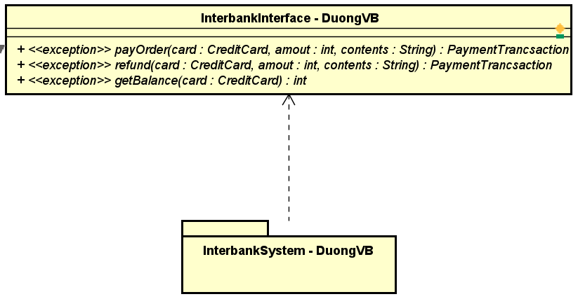

Hình 4.1. Interbank interface

1. *Thiết kế Subsystem*

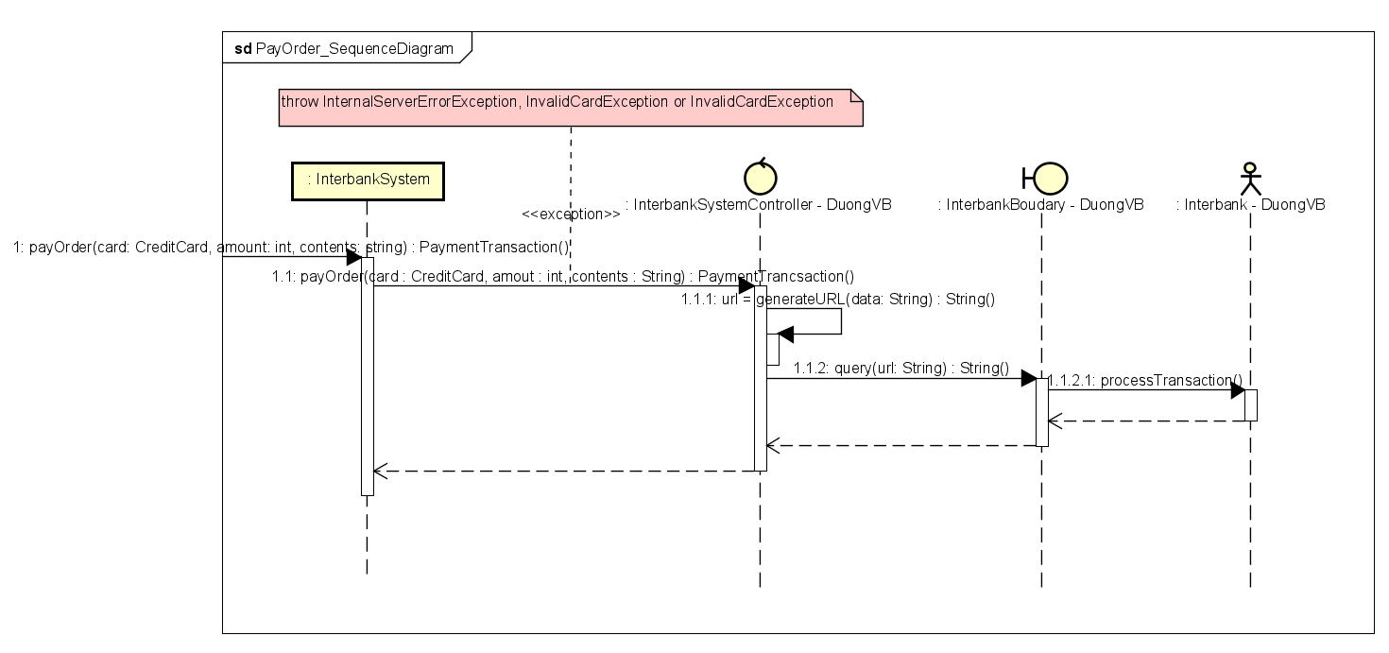

Hình 4.2.1. Biểu đồ trình tự Pay Order

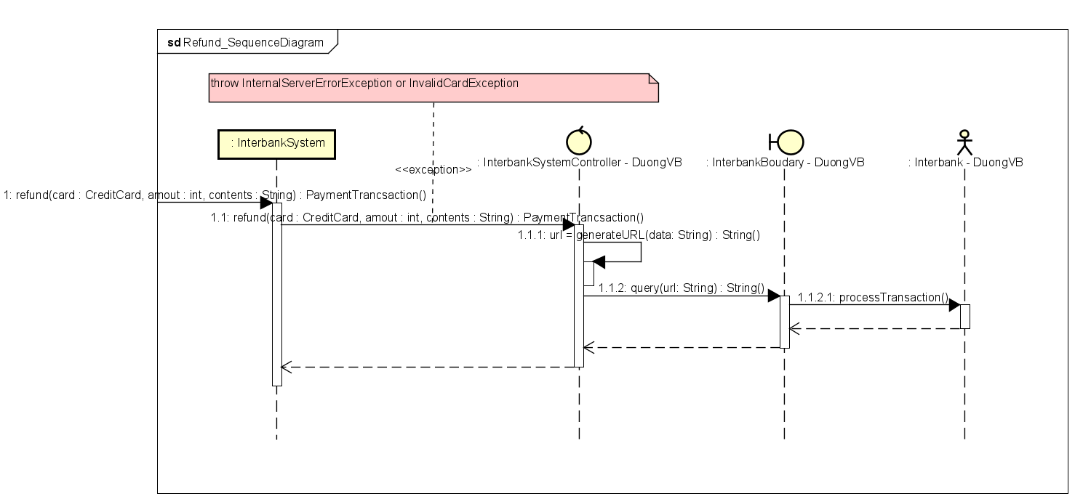

Hình 4.2.2. Biểu đồ trình tự Refund

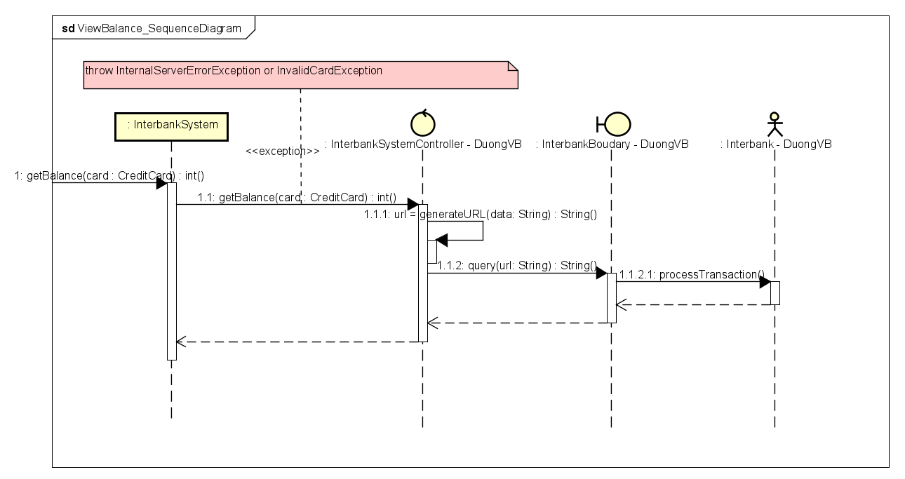

Hình 4.2.3. Biểu đồ trình tự Get Balance

***Checkpoints:***

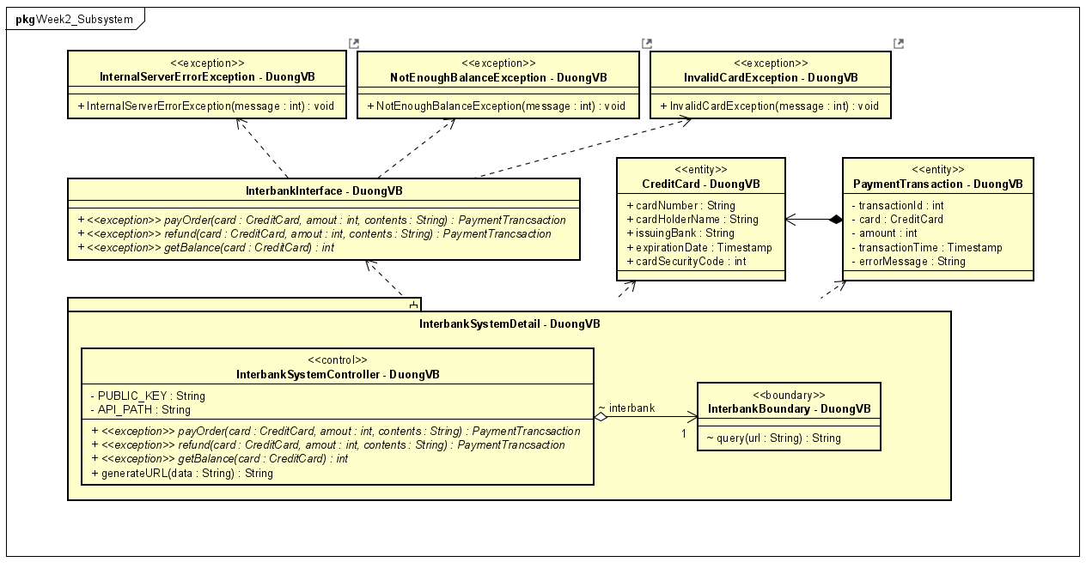

Hình 4.3. Biểu đồ lớp chi tiết của Subsystem – InterbankSystem

**V. Thiết kế giao diện Place Rush Order**

***Thêm button ở Cart Screen để chuyển sang màn hình place rush order.***

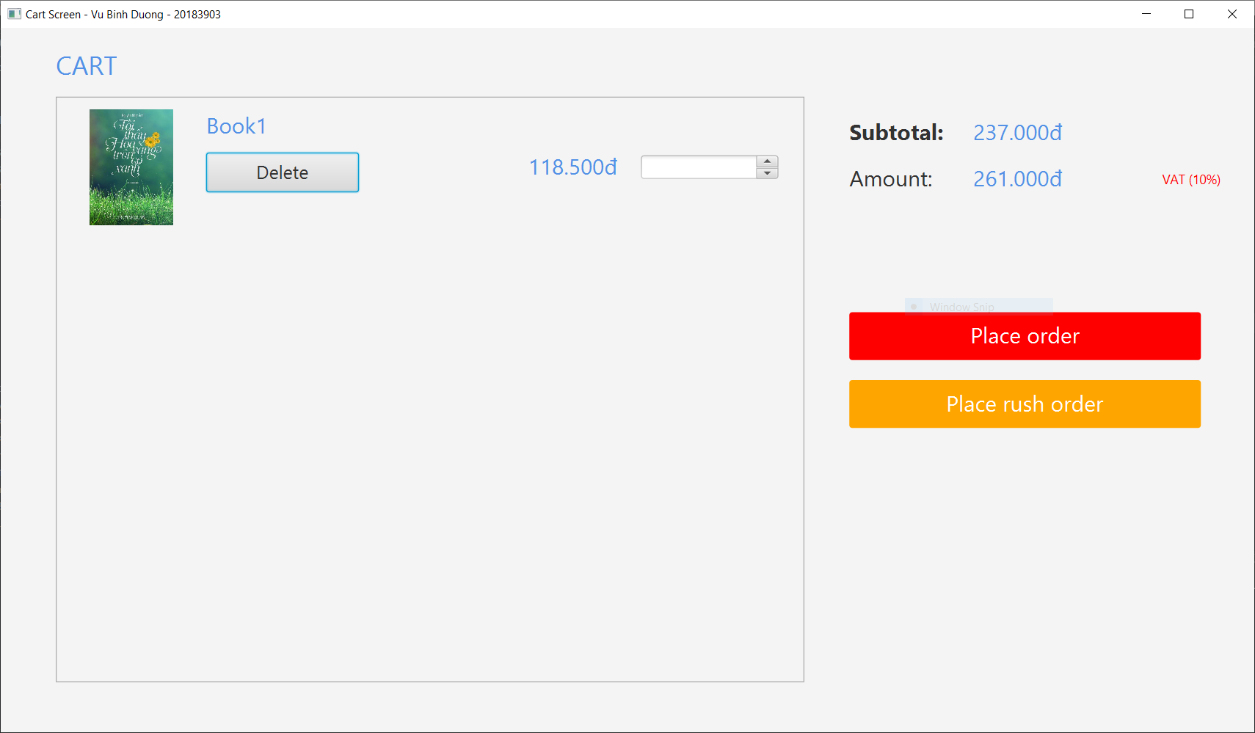

Hình 5.1. Cart Screen

***Giao diện Place rush order***

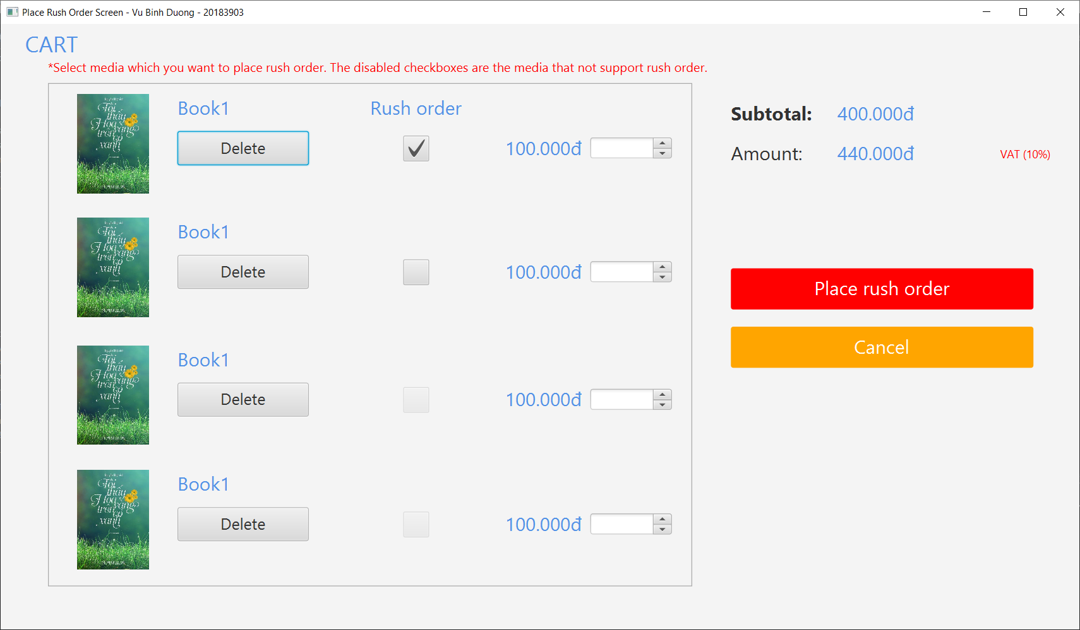

Hình 5.2. Place Rush Order Screen

***Cập nhật lại sơ đồ chuyển màn hình:***

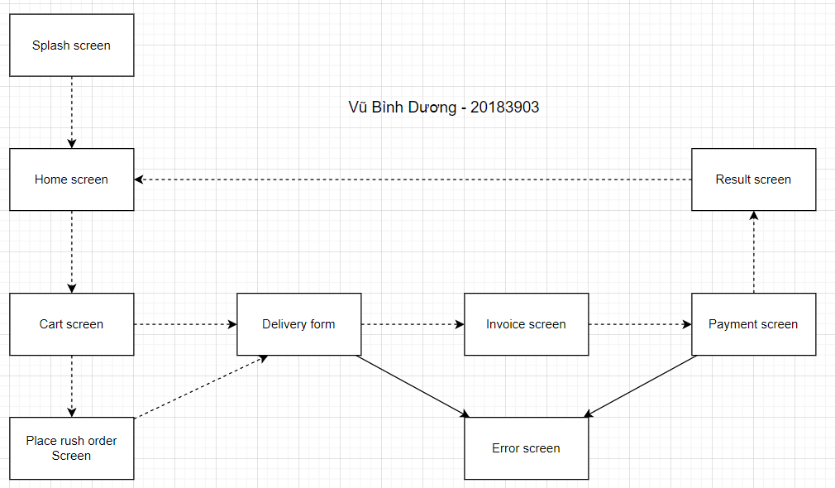

Hình 5.3. Sơ đồ chuyển màn hình

***Mô tả màn hình:***

|  |  |  |  |  |  |
| --- | --- | --- | --- | --- | --- |
| AIMS Software | | Date of creation | Approved by | Reviewed by | Person in charge |
| Screen specification | Place rush order | 2/11/2021 |  |  | Vũ Bình Dương |
|  | | Area for displaying list media in cart | Initial | Display list media in cart, media not support rush order will be disabled | |
| Area for displaying the amount | Initial | Display the subtotal, amount and VAT | |
| Place rush order | Click | Place rush order | |
| Cancel button | Click | Return to Place order screen (Cart screen) | |
| Spinner | Click | Adjust the number of selected media | |
| Rush order | Click | Choice selected media is rush order or not. Disabled when the selected media is not support rush order. | |
| Delete button | Click | Remove the item from the cart | |

#### Định nghĩa các trường thuộc tính

|  |  |  |  |  |
| --- | --- | --- | --- | --- |
| Screen name | View cart |  |  |  |
| Item name | Number of digits (bytes) | Type | Field attribute | Remarks |
| Media title | 50 | String | Blue | Left-justified |
| Price | 20 | Numeral | Blue | Right justified |
| Subtotal | 20 | Numeral | Blue | Left-justified |
| Amount | 20 | Numeral | Blue | Left-justified |